ECE2810 Digital Systems Design Laboratory

Lab 0
Introduction, Policies, and Warm-up Practice

School of Science and Engineering
The Chinese University of Hong Kong, Shenzhen

Lab Policy
The following policies and precautions are strictly enforced. Coming to the lab:
- Be punctual. Attendance is taken for the first session of each lab.
(Starting your experiment)
- Food and drink are not allowed in the lab.
- Always double-check your circuit before connecting to the power supply.
- No wiring when the electricity is on. Disconnect from the power supply when you change your circuit.
- Report any equipment failures to the TA. Be careful with all equipment in the lab, as many of the units are very costly to replace!
(High voltage precaution)
- Obtain permission before operating any high-voltage equipment.
- Never, ever modify, attach, or otherwise change any high voltage equipment.
(Leaving the lab)
- Clean up your work area before leaving. Power off all equipment.
- Wash your hands after leaving the lab and before eating.

Some useful tips may significantly save your time:
- Read the instruction and operation manual to understand the equipment. The instruction and operation manual are in BB/content/.
- When you observe something unexpected, follow these steps: first, check your circuit (especially connectivity); second, check the lab manual; and third, check the equipment manual (especially the settings and connectivity).
- For a new component (e.g., diode, LED) or IC, read the datasheet first. Typically, check the power supply requirements, positive and negative terminals, and the connection requirements. (Caution: a simple mistake can cause half an hour of debugging and ruin an hour of effort!)
- Always have a pen and paper draft and check your idea before the experiment.

Make-up labs: You are guaranteed a workstation in the lab during the allotted time. If you cannot complete the lab, there may be a make-up session. Note that you are still encouraged to submit a lab report even if you cannot complete the lab.

Course Introduction
Welcome to ECE2810 Digital Systems Design Laboratory. The objective of this document is to provide you with a guide to complete the laboratory experiments. General lab policies of labs, report format, and grading policies are provided in this document. In the first lab practice, you will learn to use some basic equipment in the lab, connect wires, and develop a circuit that will be used in your future labs.

The course aims to strengthen students’ capability in digital logic systems by means of a series of hands-on laboratory practices in digital system design. The experiments involve digital logic simulation software (e.g., MultiSim), logic gates, combinational logic, truth table, Karnaugh map, encoder/decoder, flip-flop, counter, shift register, memory, FPGA/VHDL.

2.1 Information
- Time: 3:00-5:50 pm, Thursday / 9:00-11:50 am, Friday
- Venue: RA 207/208
- Instructor: Prof. Yi Chen (yichen@cuhk.edu.cn),
Prof. Yaojing Zhang (yaojingzhang@cuhk.edu.cn)
- Lab #1-3, teaching assistants:
  - Bei Shi (224010096@link.cuhk.edu.cn)
  - lv Shihan (225010002@link.cuhk.edu.cn)
  - Zheng Jiayou (224010093@link.cuhk.edu.cn)
- Lab #4-6, teaching assistants:
  - Wang Taoyang (224015085@link.cuhk.edu.cn)
  - Du Xinnong (224010188@link.cuhk.edu.cn)
  - Li Yiyang (222010039@link.cuhk.edu.cn)

2.2 Schedule
There are 7 labs in total, spanning various weeks. Lab #0 takes one week, Labs #1-4,6 are supposed to be completed within two 3-hour sessions in two consecutive weeks, while #5 spans 3 weeks. The contents are shown in Table 1.
Table 1. Seven labs.
Week | Experiment Content
1 | Lab 0: Laboratory policies, report format, and warm-up lab practice
2-3 | Lab 1: CMOS and TTL, parameters in gate datasheet, basic experiment on AND and NOT gates
4-5 | Lab 2: Simulation software, logic gates AND/OR/NAND/NOR/XOR/XNOR
6-7 | Lab 3: Combinational logic with NAND/NOR, truth table, and Karnaugh map
8-9 | Lab 4: Functions of combinational logic, 7-Segment Display, Decoder
10-12 | Lab 5: Flip-flop, Counter, Responder
13-14 | Lab 6: FPGA and VHDL

2.3 Grading Policies
Lab 0 is not graded. Labs 1—6 are graded based on lab performance and lab report. The overall grade consists of two parts in Table 2.
Table 2. Final score.
Parts | Percentage
Lab performance | 50%
Lab report | 50%

Table 3. A sample check table.
Lab performance: Each lab consists of a number of stages or checkpoints. When you complete a stage, check it by yourself, and then demonstrate it to our TA, who will mark it down on a check table (Table 3). Certain points will be earned for lab performance. (Do not forget to take photos and mark down the data, which will be useful in writing a lab report.) In addition, the following items also affect your lab performance:
- Lab attendance: Sign up in the attendance form in the first session of each lab.
- Lab clean-up: Clean up the space when you leave the lab and power off all equipment. Our TA will check your workstation and mark it down if you violate this policy; a deduction may apply.

Lab report: Summarize your experiment, data, findings, and discussion by writing a scientific report. Grading will be based on the rubric below.
- Correct format [20%]
- Content (i.e., items requested in lab, complete design procedure, etc.) [60%]
- Questions (answer the experiment-related question posted in the lab manual) [10%]
- Presentation (i.e., organization, neatness, language, level of effort) [10%]

Suggested Report Format (Please check out the report template on the BB.)
- Cover page: You should include your name, the course number and title, and the date.
- Design: This section contains the designed circuit diagram, truth tables, K-maps, source code, etc. Each of these items should include a written description in text. Simply including a circuit diagram is not sufficient.
- Results: Use this section to discuss the observations you made during the lab. Be sure to include an adequate description in the body of text.
- Conclusion: This section should briefly summarize what you have done and provide some insight you have learned.
- Questions: Finally, you should thoroughly answer the questions provided in each lab. A brief one-line answer is NOT acceptable.

An Important Note on Plagiarism: Students shall pay attention to the University policy and regulations on honesty in academic work, and to the disciplinary guidelines and procedures applicable to breaches of such policy and regulations. Plagiarism is considered a disciplinary offence which can result in reduced grades, failed subjects, and suspension from the University. If plagiarism is detected in any images, data, answers to questions, etc., the report will be scored 0!
Hint: DO NOT let others copy your work!

Important Hints and Lessons Learned from Previous Years
A majority of students can finish each lab in 4-5 lab hours. In case you have encountered difficulty, you probably need to improve in the following aspects.
- Read EVERY word slowly and carefully in the lab manual: Do not simply use your imagination, which could probably be wrong. (Strongly suggest you print out the lab manual.)
- Get familiar with the equipment first: Please read and search the instrument manual. In case we need to use some IC chips, read the IC datasheet carefully.
- Read the tutorial PPT carefully: We will summarize the most common mistakes in the tutorial PPT.
- Try to understand the logic first.

2.4 AI Policy
- Encouraged: Use AI tools, including ChatGPT, to gain more background information on the lab and search for solutions to tackle the challenges in the lab.
- Encouraged: If AI was used, write down the prompts in the lab report and discuss how to interact with the AI to discover the best solution to solving the problem.
- Prohibited: Use AI to generate lab reports or manipulate experiment data.

Lab Content
Objective: (1) Practice wiring and developing a circuit for input and output. (2) Make a circuit board. The circuit consists of two modules, i.e., switch input module (SIM), and LED output module (LOM). SIM can work as the input for your digital circuit by feeding 8 digital outputs, while LOM can show the output of your digital circuit by its 8 LEDs. From a TA or lab engineer, you can take the components needed as shown in Table 4.

Table 4. Components in Lab #0
Breadboard ×1 | Box of wiring ×1
General-purpose PCB ×1 | 1k resistor ×16
8-channel DIP switch ×1 | LED ×8
20-channel Dupont cable ×1

The tools in Table 5 needed include a pair of wire strippers and diagonal pliers. Do remember to put them back into the drawer after the lab.

Table 5. Other tools
Wire strippers ×1 (Optional)   | Diagonal pliers ×1  

Step 1: Breadboard Wiring
Investigate the circuit diagrams in Figure 1. Each diagram shows one channel of SIM and LOM. R₁=R₂=1kΩ. Wire them in the breadboard and realize an 8-channel system (i.e., 8 switches and 8 LEDs).
Figure 1. SIM and LOM circuit diagrams. (a) One channel in LOM. (b) One channel in SIM.
Pay attention to the polarity of the LED in Figure 2. We can use a multimeter to determine LED polarity as shown in Figure 3. To determine LED polarity using a multimeter, first rotate the selector knob to the Ohms (Ω) measurement position. Then, press and hold the yellow function button in the top-right corner to enable diode () test mode. Finally, firmly contact the LED pins with the multimeter probes. The forward-biased connection turns the LED ON and reveals the anode, while the reverse-biased connection keeps the LED OFF.
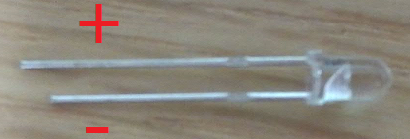
Figure 2. LED polarity.

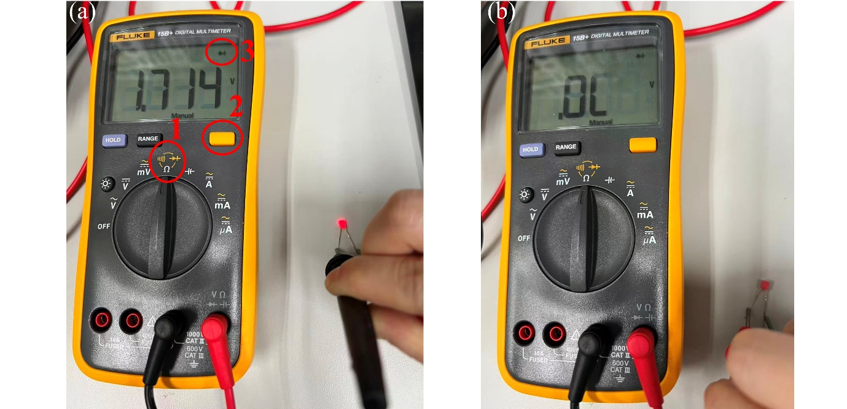
Figure 3. Using a multimeter to identify the anode and cathode of an LED based on its (a) light emission and (b) no light emission.

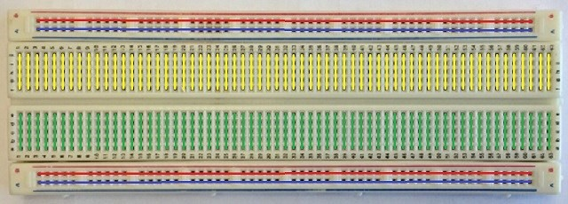
Figure 4. Breadboard illustration.

A breadboard in Figure 4 is a plastic board with a bunch of tiny holes and is used for building and testing circuits. The holes on the breadboard are internally connected in a specific pattern. The holes that are connected through the green line represent that they are connected internally. The Red line indicates Power, which is normally connected to the power rail. The Blue line indicates Ground, which is normally connected to the ground of the circuit. ICs like Decade Counter can be placed in the middle breadboard to share the 1st eight pins to the yellow line and the 2nd eight pins to the green lines. In Figure 5, we made a circuit for a glowing LED on a breadboard.
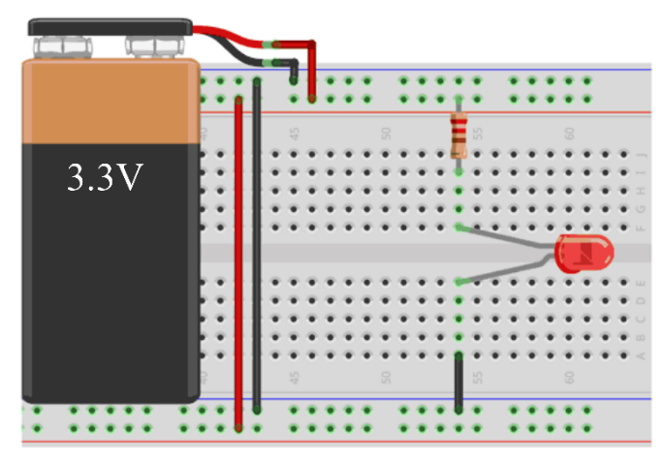
Figure 5. A glowing LED on a breadboard.

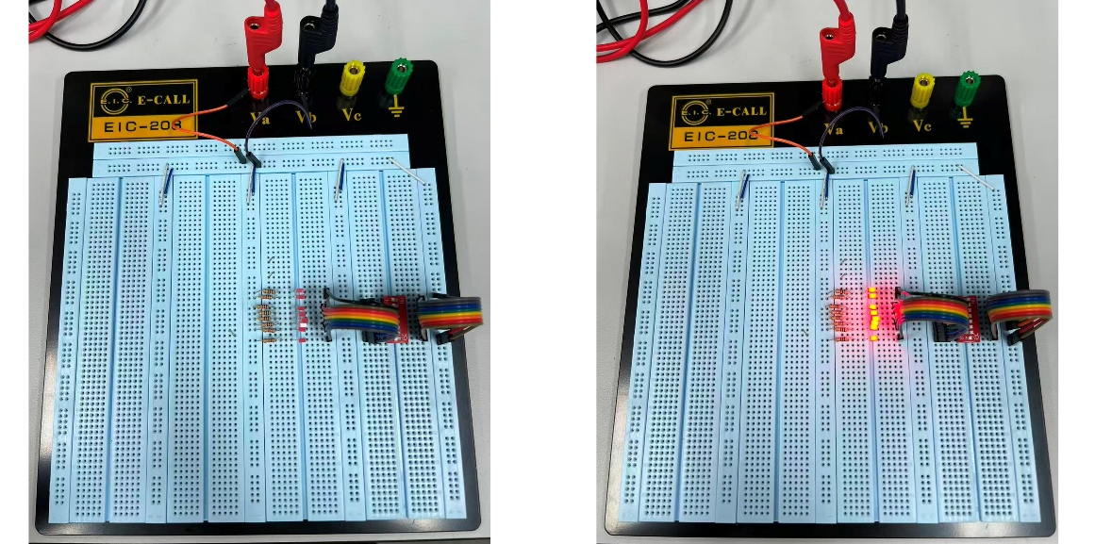
Figure 6. An 8-channel DIP switch system with the switch (a) in the OFF state and (b) in the ON state.

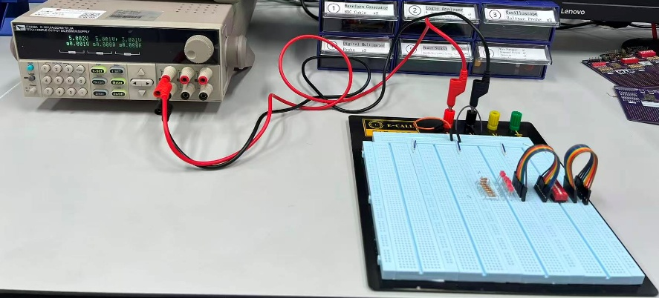
Figure 7. Experimental setup to test the 8-channel DIP switch system.

- Test step 1: The 8-channel DIP consists of 8 parallel switches. Take eight 1kΩ resistors, eight LEDs, and one 8-channel DIP switch to build an 8-channel DIP switch system, as shown in Figure 6(a).
- Test step 2: Following the experimental setup in Figure 7, connect the switching system to a DC power supply.
- Test step 3: Set V_{CC}=5.0V in DC power supply. Turn on the 8 sub-switches and observe the LED status. If the wiring is correct, you will see the eight LEDs light up as indicated in Figure 6(b).
[Demo] Demonstrate to your user that all 8 channels of your 8-channel DIP switch system are illuminated correctly. (You probably need a voltage source and some wiring on the breadboard.)

Step 2: General-Purpose PCB Development
Now, you can use a blank printed circuit board (PCB) to develop SIM and LOM as shown in Figure 8(a), which will be used in our future labs. Move the eight resistors used above, the eight LEDs used above, the other eight 1kΩ resistors, and the pin headers to their corresponding locations on the PCB and solder them using the soldering station (Figure 9). The soldered PCB is shown in Figure 8(b).
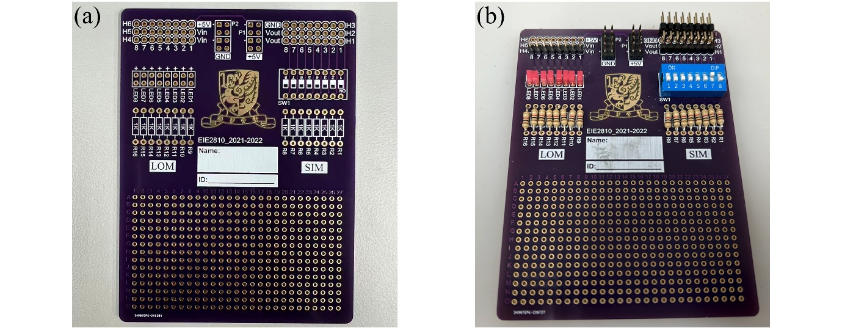
Figure 8. Two PCBs (a) A blank PCB. (b) A soldered PCB with multiple components.

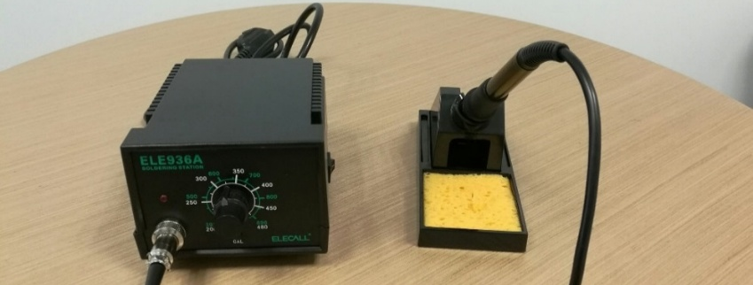
Figure 9. Soldering station.

Test: Use the handheld multimeter to check the continuity, as shown in Figure 10. Turn to position “1” and press the button marked as “2” once. You will see the display marked as “3”. When the two measured points are short-circuited, there will be a “BEEP”. This will help you check the signal connectivity and check for unwanted SHORT CIRCUIT.
Figure 10. Handheld digital multimeter.

[Demo] Demonstrate to the TA that your SIM-LOM is functioning. (You probably need a voltage source and some wiring on the breadboard.)
Tips:
- When you carry out the soldering work, refer to the Appendix. Wear the safety glasses. Remember, the most important thing is your SAFETY!
- Make sure NOT to short two different pins. You should check their continuity with a handheld multimeter from time to time.
- For SIM, you should have the following wires for connection to the external circuit in the future: V_{CC}, GND, and 8 channels of outputs.
- For LOM, you should have GND and 8 channels of inputs.
- After completion of SIM and LOM, repeat steps 1-3 above.

Before Leaving the Lab
Before you leave the lab, follow the steps below:
- Mark your name on the developed SIM-LOM, your breadboard, and the plastic box.
- Clear and sort the remaining wires and components in the breadboard. Put SIM-LOM and the sorted wires into your plastic box and put it on the shelf in the storeroom.
- Put the wire-stripper and diagonal pliers into the drawer of the workbench.
- Clear the bench, place the oscilloscope, DC power supply, signal generator, bench-top multimeter, and handheld multimeter appropriately.
- Power OFF the equipment.
- Alter the TA to check your workstation, if applicable.

Appendix: Basic Equipment
In this lab, you will need to use a handheld multimeter, DC power supply, and soldering station. For other equipment, we will leave it in the labs when needed.

4.1 Handheld Multimeter (not Bench-Top Multimeter)
A handheld multimeter is one of the most commonly used equipment. We are using a FLUKE 15B+ digital multimeter. It has two probes. The red one can be inserted into three sockets, one for measurement of voltage/resistance/capacity/continuity-check, one for large current (A) measurement, and the other for mA/µA measurement. The black probe is common for all measurements. You should pay attention to the maximum measurement capability before connecting to the circuit.

4.2 DC Power Supply
We are using ITCH IT6332A (Figure 11). The majority of you have learnt in last semester's lab on circuits. If you have any questions, you can ask the instructor, teaching assistant, USTF, or lab engineer.
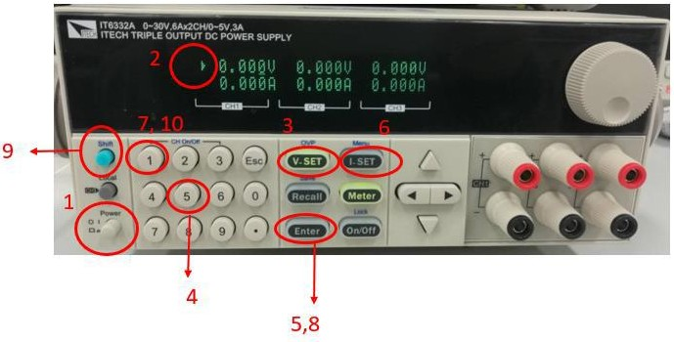
1. Power on the DC power supply.
2. Check that a triangle in the screen is pointing to CH1. This indicates that you can setup CH1.
3. Press V-SET. This will allow you to set voltage. Then the light of V-SET will be on. By default, V-SET is on, when you power on the power supply.
4. Press 5, and then press ENTER, so as to set voltage to 5V.
5. Press I-SET. This will allow you to set current.
6. Press 1 and then ENTER, so as to set maximal current to 1A.
7. Press Shift. This will allow you to choose the functions above a certain number of buttons.
8. Press 1 again. With the function of Shift, CH1 is switched on.
Figure 11. DC power supply.

Appendix: Instructions for the Soldering Station
- Refer to [1] and put on the safety glasses. Keep loose clothing and hair out of the way.
- Keep the sponge wet in the soldering station. But also, do not pour too much water.
- Turn on the soldering station and select an appropriate temperature. In general, 270-320 °C will be enough. The LED in the station will be on when heating. If there are any instructions on the maximum temperature in the component, you need to comply with that. Otherwise, it will damage the component.
- When the tip is fully heated, the LED will flash. You are ready to carry out the soldering work. The most IMPORTANT thing is your SAFETY. Be careful with your fingers.
  - Put the component that should be soldered in the appropriate place.
  - Hold the iron in your dominant hand. Softly scrape the tip against the sponge to remove old solder.
  - Hold a long piece of solder in your other hand. On the hot iron, carefully apply a small amount of fresh solder and coat the tip.
  - When soldering two components together, touch the area where they join with the soldering iron. Hold the tip there for about a second, then slide the solder underneath the tip of the iron, sandwiching it to the PCB (refer to the image below, cursor points to solder). Hold the solder for another second or two, feeding in how much solder you need.
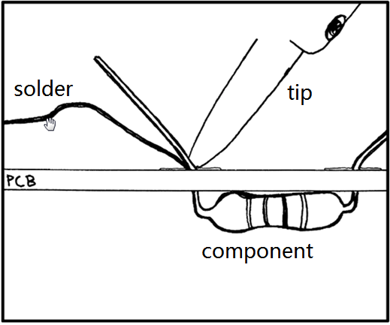
  - Pull away the solder first, and continue holding the iron for another second. This allows the solder to continue to melt and pool, forming a good joint. Then, you can remove the iron tip. The total process shouldn’t take long.
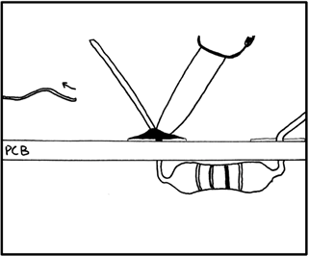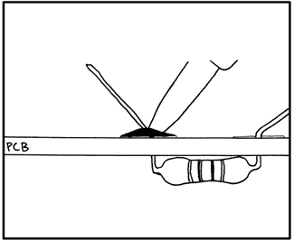
  - Wait a few seconds and don’t disturb the solder. It cools very quickly, but moving or blowing on the joint will cause it to deteriorate.
  - Repeat in the next components.

Reference
[1] http://www.howtogeek.com/63630/how-to-use-a-soldering-iron-a-beginners-guide/

